**DAILY ONLINE ACTIVITIES SUMMARY**

|  |  |  |  |  |  |  |  |  |
| --- | --- | --- | --- | --- | --- | --- | --- | --- |
| **Date:** | **16/06/20** | | | | | **Name:** | **Gulam Rabbani** | |
| **Sem & Sec** | **4th Sem “B” Section** | | | | | **USN:** | **4AL18CS099** | |
| **Online Test Summary** | | | | | | | | |
| **Subject** | | **Maths** | | | | | | |
| **Max. Marks** | | **30** | | **Score** | | | **24** | |
| **Certification Course Summary** | | | | | | | | |
| **Course** | [Learn Burp Suite, the Nr. 1 Web Hacking Tool](https://www.udemy.com/course/burp-suite/) | | | | | | | |
| **Certificate Provider** | | | **Udemy** | | **Duration** | | | **02:00:00** |
| **Coding Challenges** | | | | | | | | |
| **Problem Statement: 1 java program** | | | | | | | | |
| **Status: Executed** | | | | | | | | |
| **Uploaded the report in GitHub** | | | | | **Yes** | | | |
| **If yes Repository name** | | | | | **https://github.com/alvas-education-foundation/gulam_rabbani/tree/master/daily_progress** | | | |
| **Uploaded the report in slack** | | | | | **Yes** | | | |
|  | | | | |  | | | |
|  | | | | |  | | | |

Online Test Details: (Attach the snapshot and briefly write the report for the same)

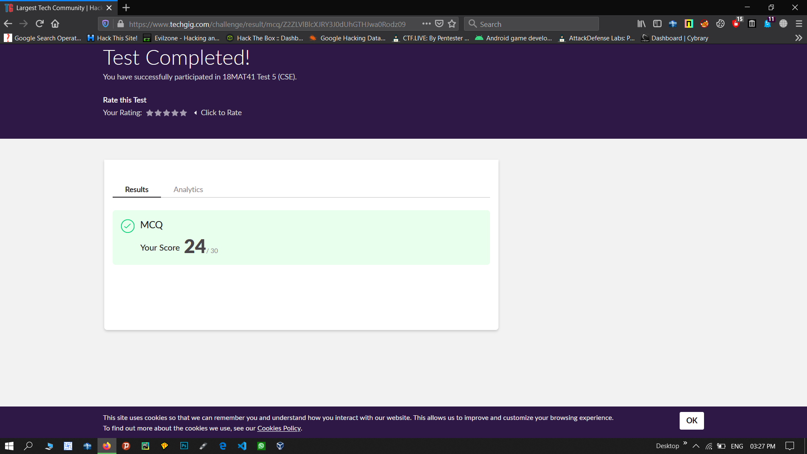

Certification Course Details: (Attach the snapshot and briefly write the report for the same)

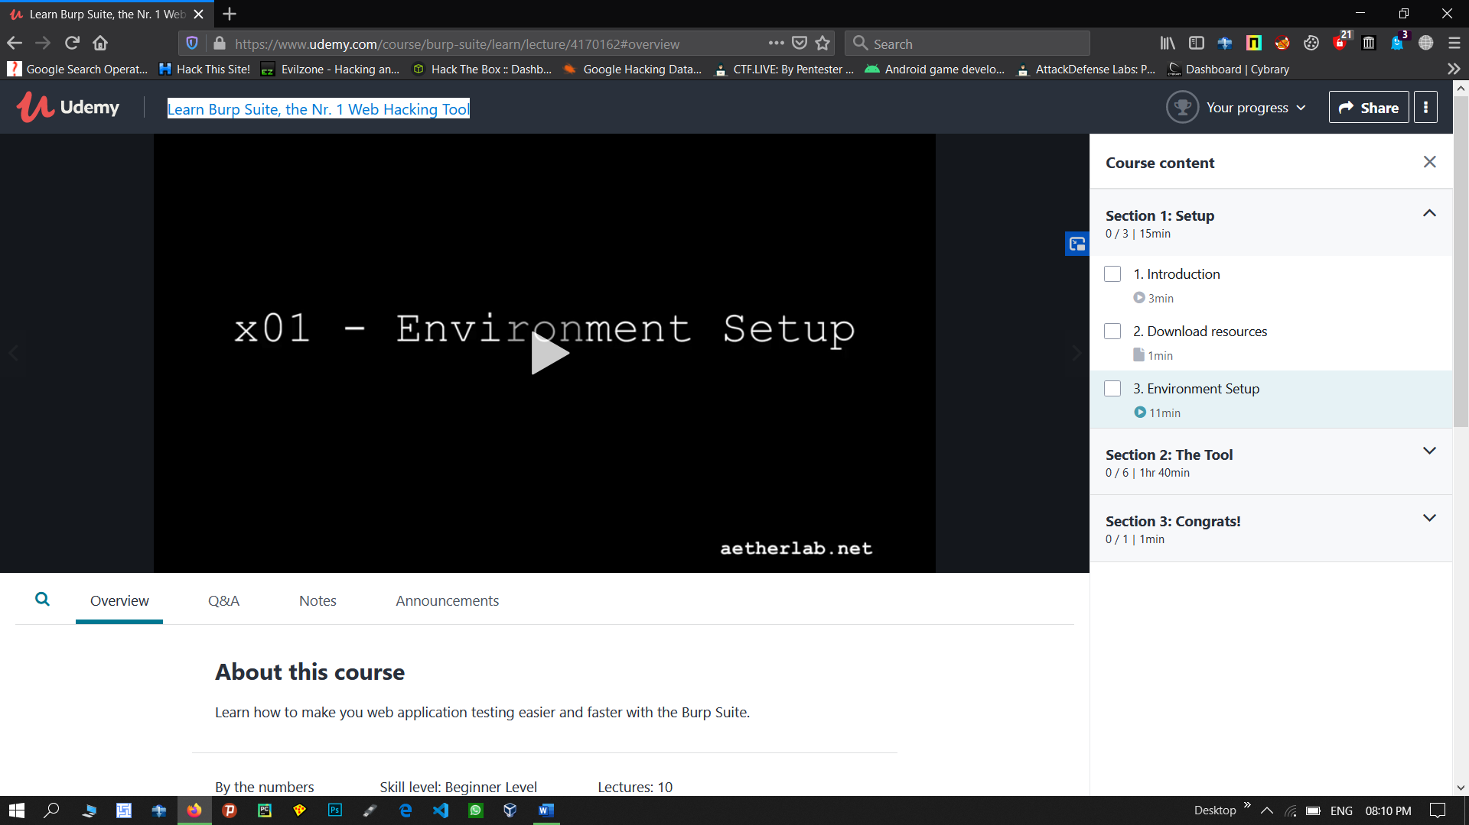

**What you’ll learn**

* Learn how to use the Burp Suite in a web application penetration test
* Through examples show you the main functionality of the Burp Suite
* Start you in your way to become an efficient penetration tester

**Are there any course requirements or prerequisites?**

* The course is not a web application hacking course. Quite a few web vulnerabilities will be shown in the examples, however, the focus will be on the Burp Suite. Still if you want to learn web hacking, it will be still good to kickstart it, just don't expect the course to cover everything.
* To do the course you will need the free edition of Burp Suite and the Owasp WebGoat, both are available for free. I will use the Kali linux as my operating system, but that is optional.

Coding Challenges Details: (Attach the snapshot and briefly write the report for the same)

